Portia Ocran

991545021

PROG 32758

Professor Alaa Salih

December 2, 2019

**Mercury Medical Walk-In Clinics System**

Mercury Medical Walk-In Clinic System is a web application created using JSP, Java Servlets and JSTL. It can be used by both patients and practitioners but will focus mainly on the patient. All information is stored to and retrieved from the Mercury database. The mercury database is a local database that contains 7 tables: users, practitioners, patients, appointments, addresses, provinces, and menuFunctions. All functions in the side menu are derived from the menuFuctions table. All functions are controlled by servlets, which redirect requests to the respective JSP.

**Landing Page**

When accessing the application, the user will land on the login page. If a user does not have an account, they can register by selecting the “Register Now” hyperlink.

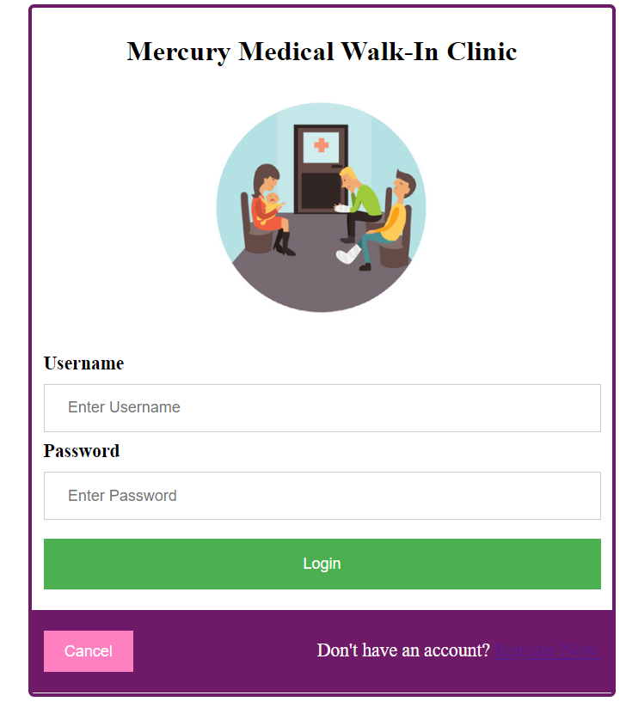

**Registration Page**

If a user does not have an account, they are able to register using the forms below. First the user enters their personal and log in information.

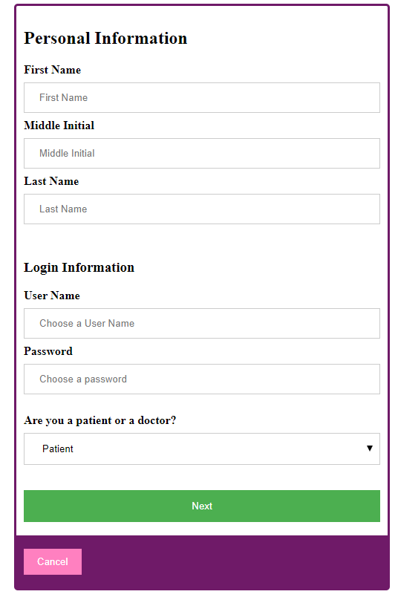

Figure : Registration Form

Once the required information has been entered, they can select whether they are a doctor or a patient. Depending on their role, they are taken to a different page.

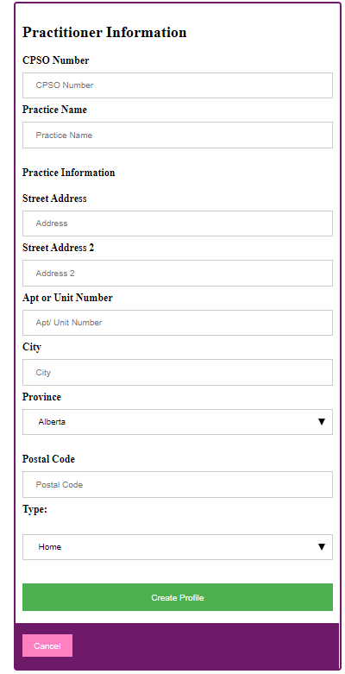 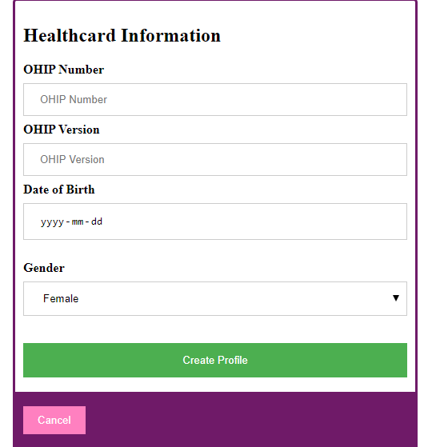

Figure : Practitioner Registration Form Figure 3: Patient Registration Form

Upon Successful creation of an account, the user login information will be stored to the user table, and the patient or practitioner will be stored to their respective databases. The user can now login.

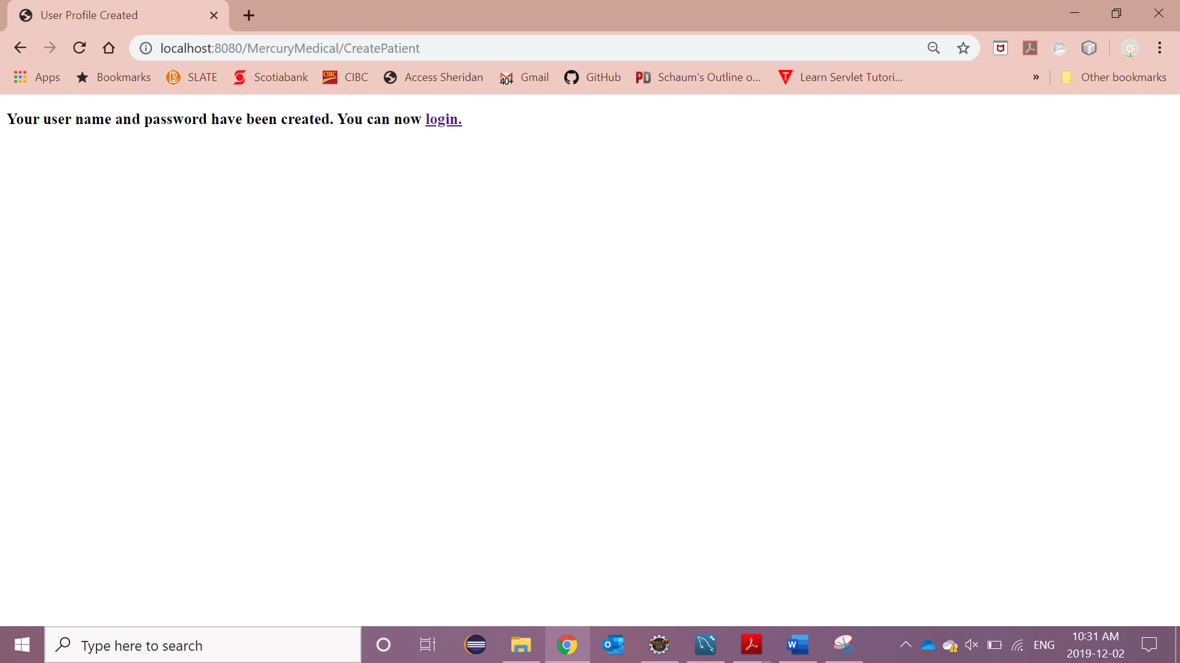

Figure 4: Successful Registration

**User Profile**

Upon successful login, the user will be taken to the User Profile page where the user’s information is displayed. The header and left menu will be displayed throughout the entire application. The values in the side menu are derived from the menu functions table in the database. The header information is dynamic and will change if the user’s first name or last name changes.

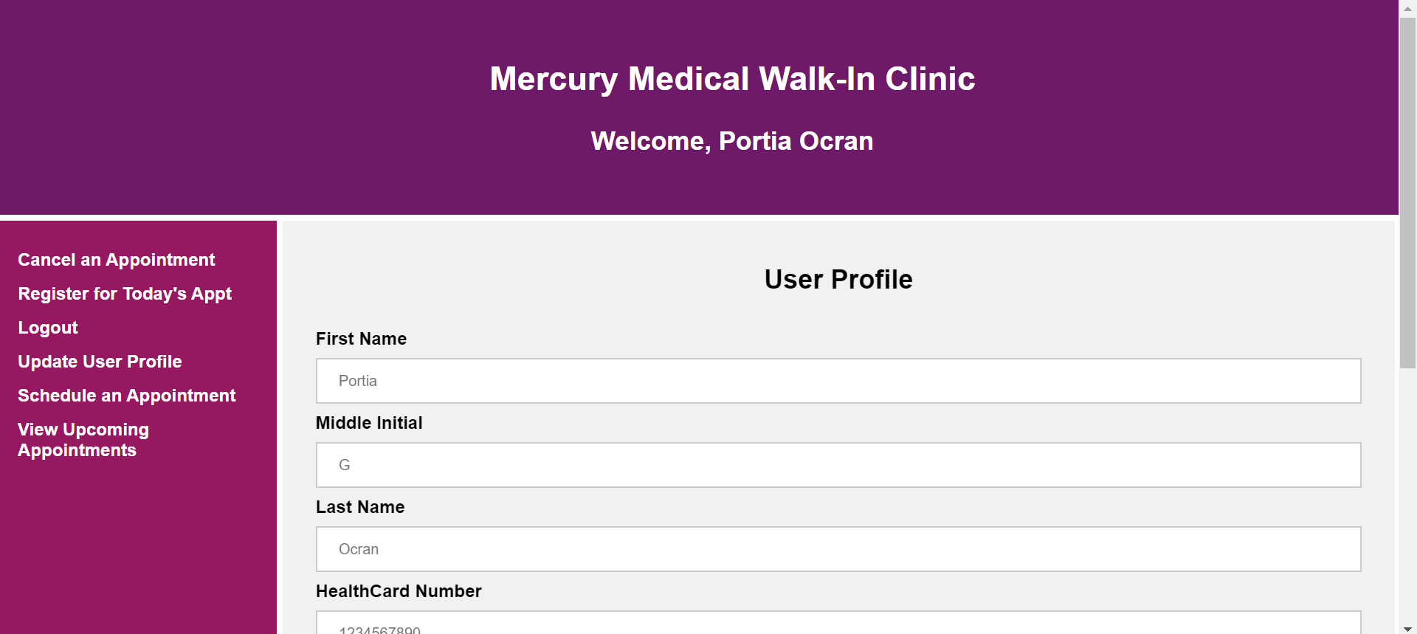

Figure 5: User Profile Page

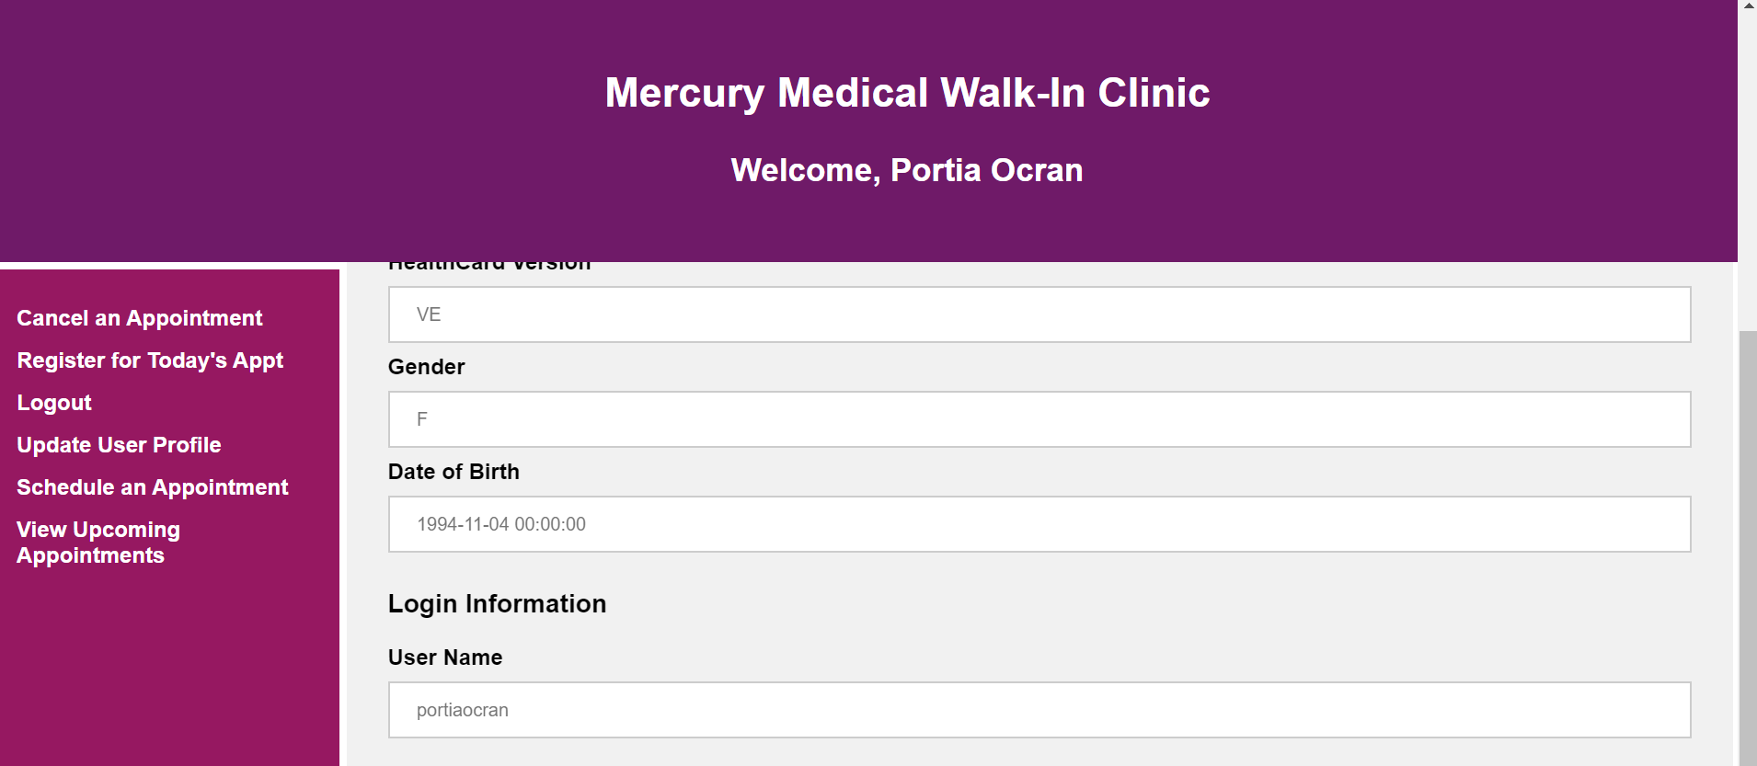

Figure 6: User Profile Page

**Schedule an Appointment**

Users can schedule appointments for a future date. To do so, they will simply fill out the book appointment form. All fields are required.

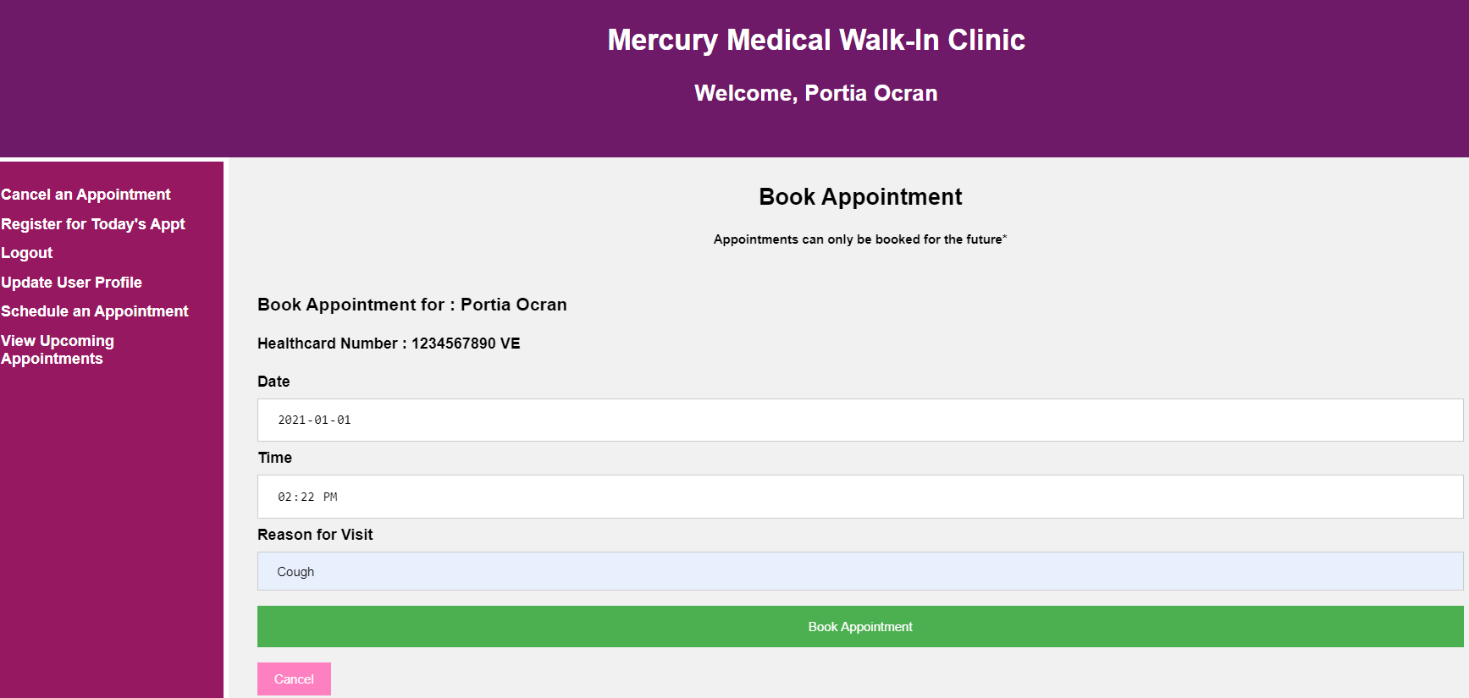

Figure 7: Book Appointment Page

Upon successful booking, a message is displayed with the booked appointment details. The appointment is now stored in the appointment table in the Mercury database.

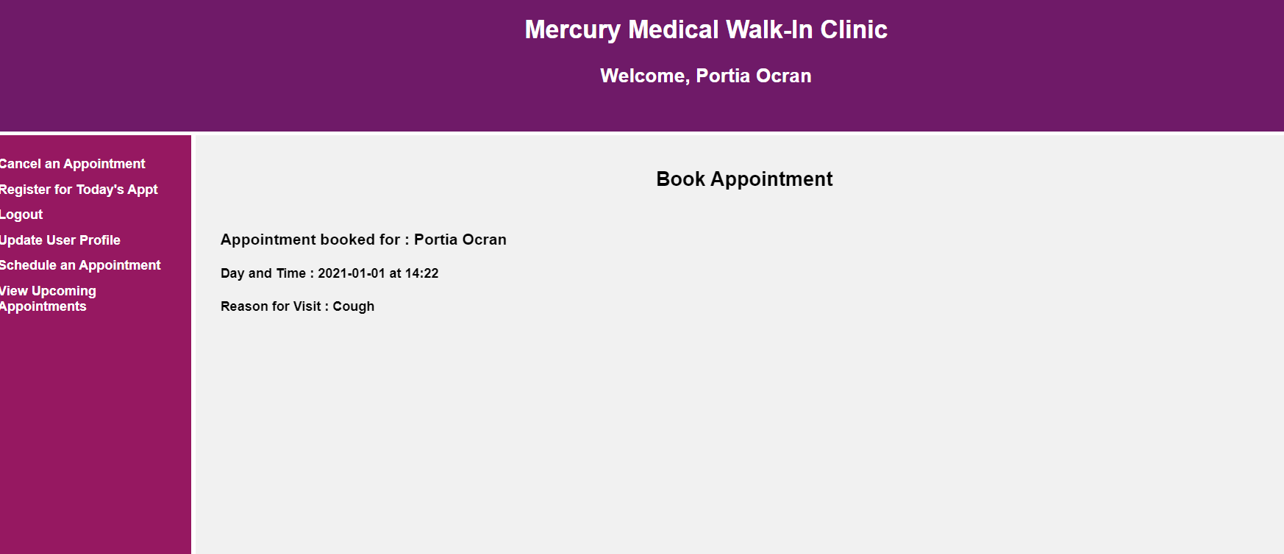

Figure 8: Successful Booking

**View Upcoming Appointments**

The user can see all upcoming appointments by selecting “View Upcoming Appointments” in the side menu. If they have no appointments, no appointments will be displayed.

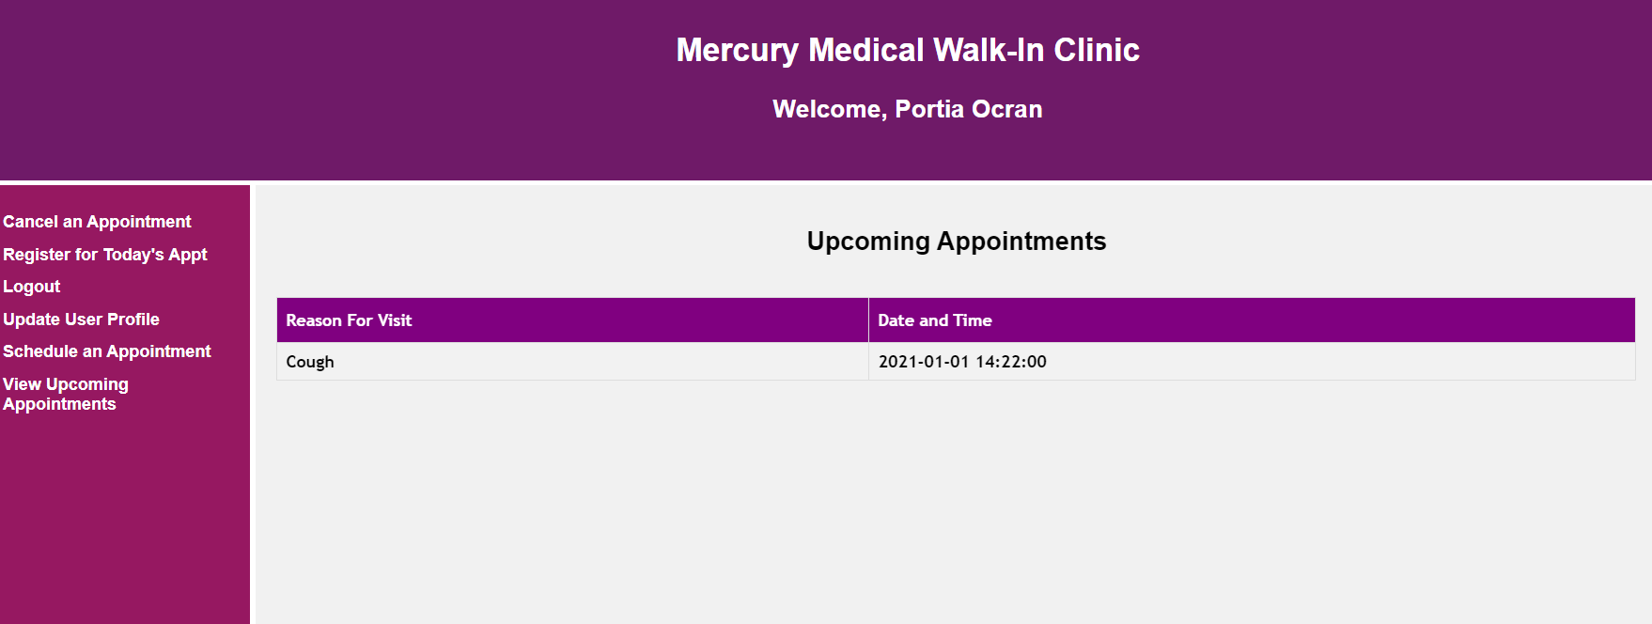

Figure 9: View Upcoming Appointments Page

Cancel an Appointment

If users have any appointments booked, they can cancel them. Using the “Cancel Appointment” function located in the side menu.

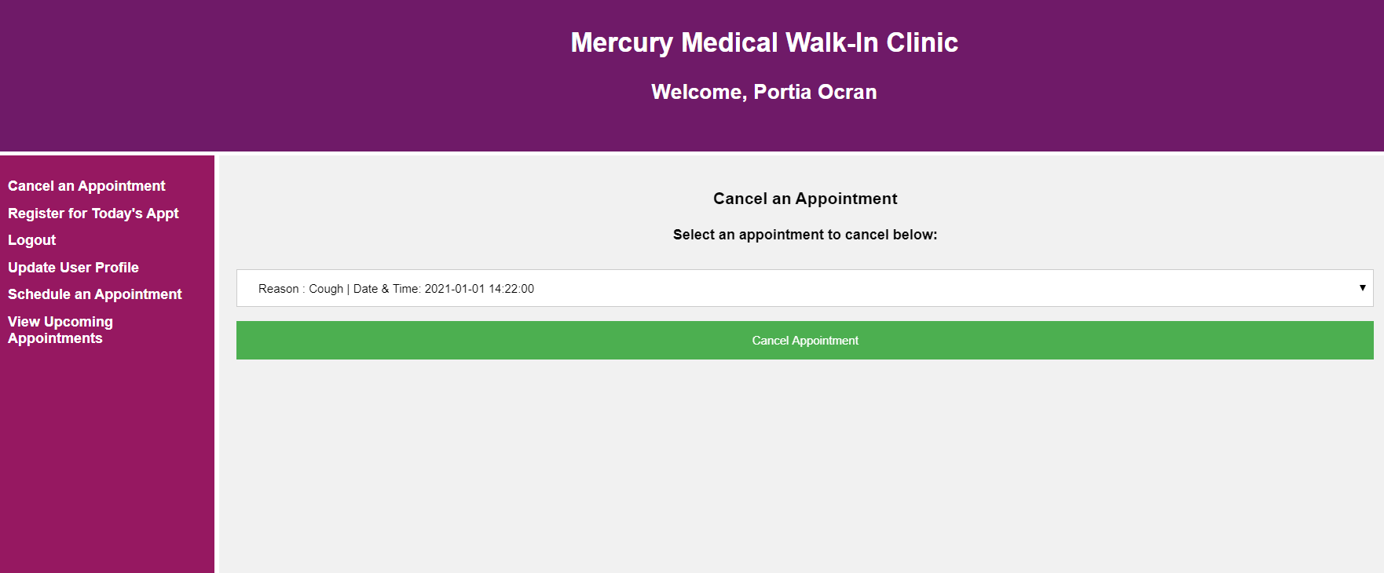

Figure 10: Cancel Appointment

Upon successful appointment cancellation, the user will receive a confirmation message. The appointment will be removed from the appointment table in the database.

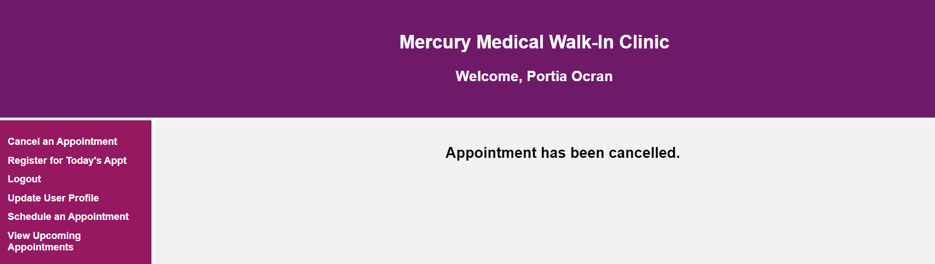

Figure 11: Appointment Cancelled Confirmation

Now that the user has cancelled all appointments, the cancellation page will appear as displayed below.

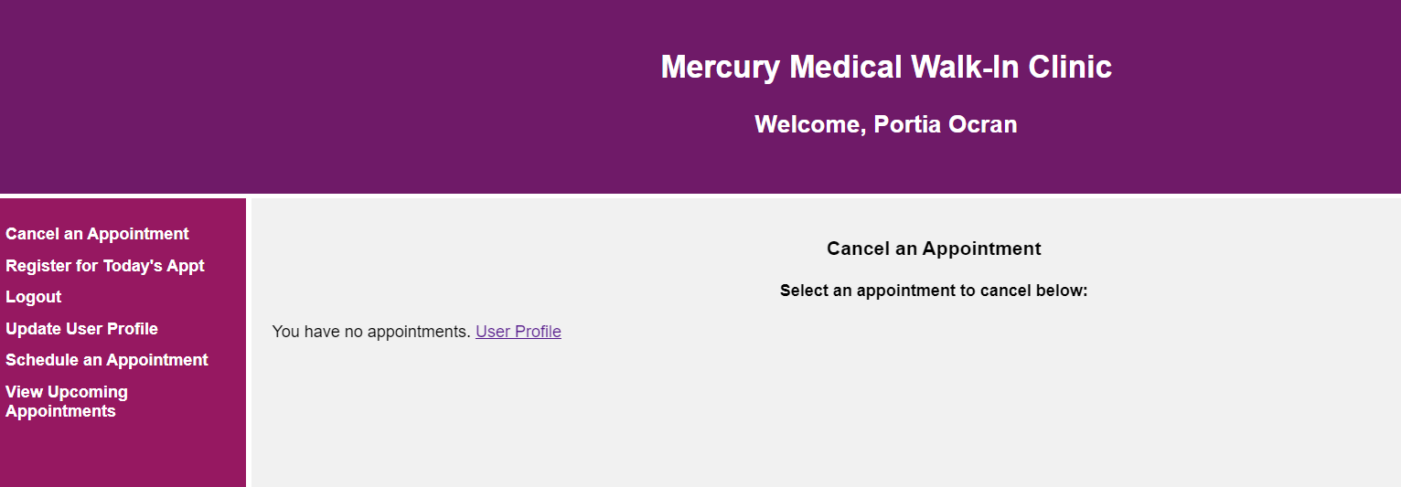

Figure 12: Cancel Appointment Page With no Appointments

**Update User Profile**

The user can update their profile information using the “Update User Profile” function in the side menu. Only the first name, middle initials, last name, HealthCard version, and password can be updated. In the example below, we will change the user’s name to Ashley Ocean.

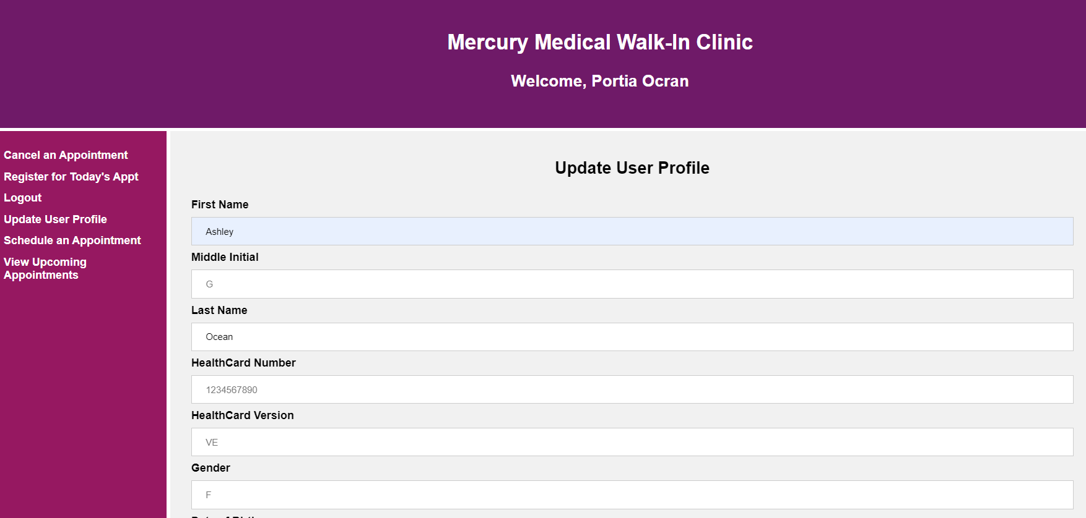

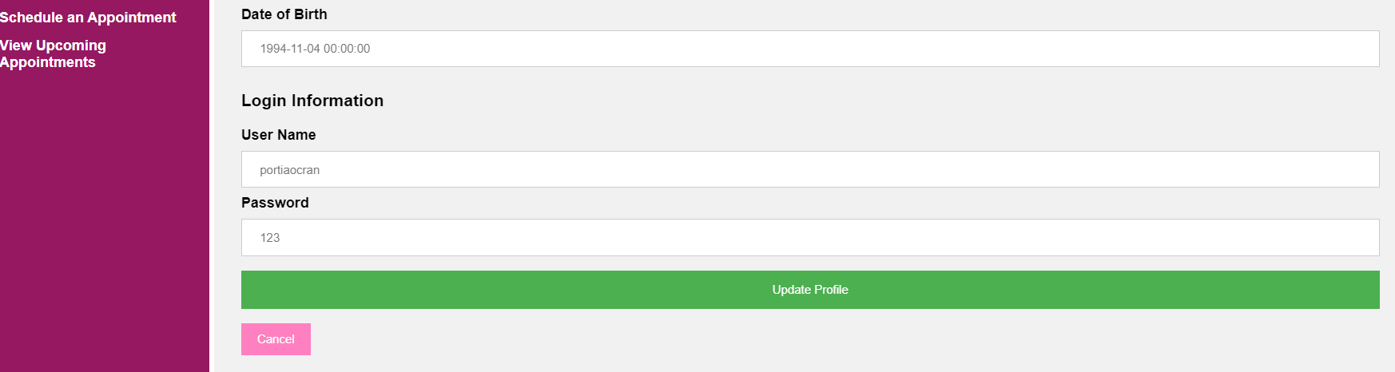

Figure 13: Update User Profile

The user will receive confirmation their information has changed. The header will reflect this change.

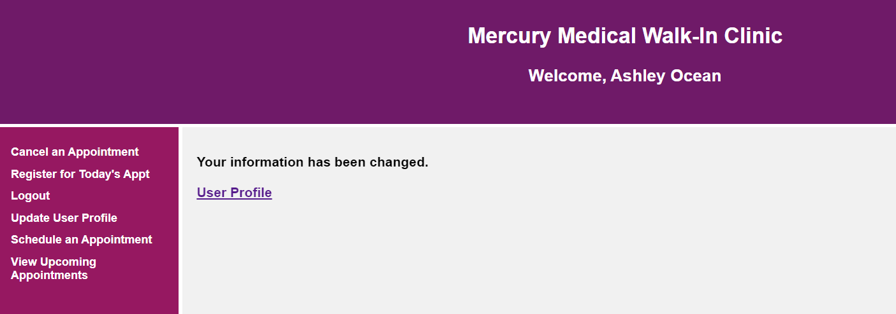

Figure 14: Profile Updated Successfully

**Register for Today’s Appt**

Users are only able to register for an appointment the day of the appointment. The user must verify that all information is correct before registering- if it is not they can update it by selecting the “Update Your User Profile” hyperlink. Once the user checks in, they cannot check in again.

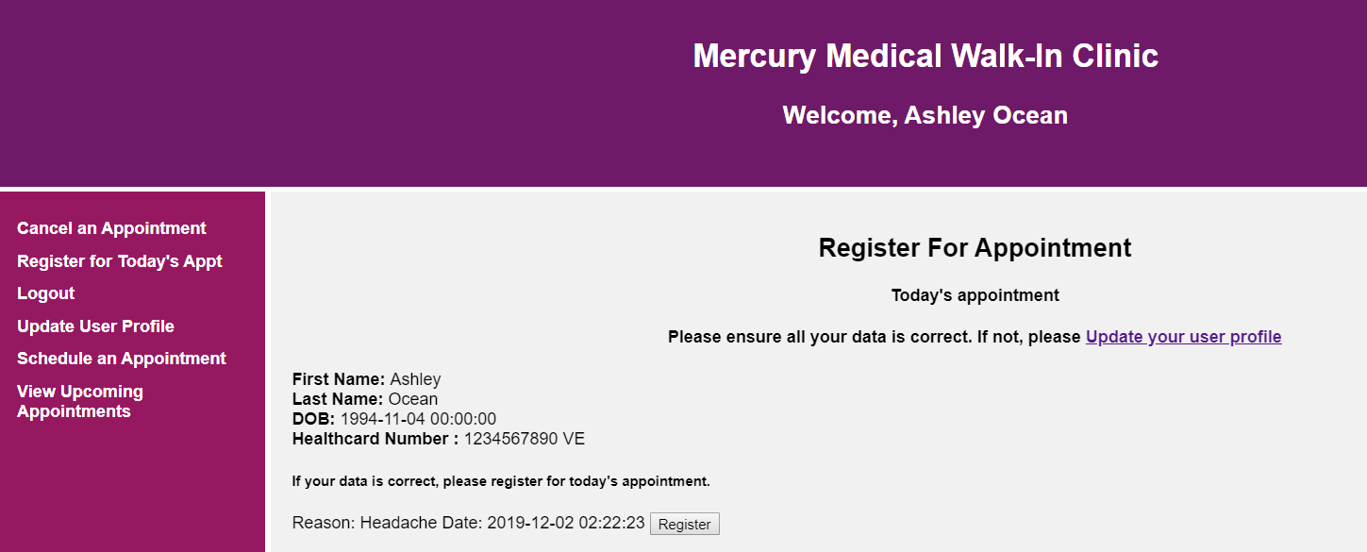

Figure 15: Register for Today's Appointment

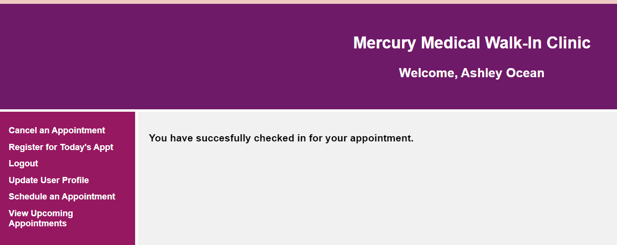

Figure 16: Successful Check-in

The user is no longer able to check-in as they have already checked in for today’s appointment.

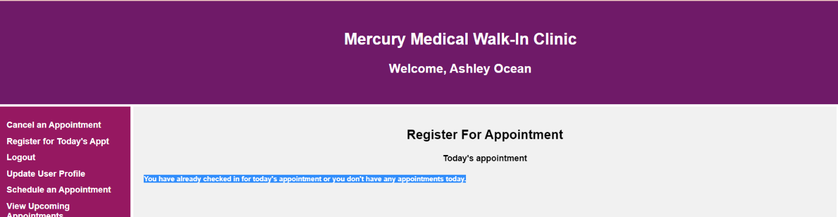

Figure 17: Registration Page with no appointment's for today/ already checked-in

**Logout**

Users can logout by simply selecting logout in the side menu function. The session will be destroyed, and the user will be taken to the landing page.